**TASK TWO: OPERATORS AND DECISION-MAKING STATEMENT**

1. Write a program in Python to perform the following operation:

* If a number is divisible by 3 it should print “Consultadd” as a string
* If a number is divisible by 5 it should print “c” as a string
* If a number is divisible by both 3 and 5 it should print “Consultadd Python Training” as a string.

def printString( num ):

    if num % 3 == 0:

        if num % 5 == 0:

            return "Consultadd - Python Training"

        else:

            return "Consultadd"

    else:

        if num % 5 == 0:

            return "Python Training"

        else:

            return "Not divisible by both 3 and 5"

num = 15

result = printString(num)

print(result)

2. Write a program in Python to perform the following operator-based task:

* Ask user to choose the following option first:
  + If User Enter 1 - Addition
  + If User Enter 2 - Subtraction
  + If User Enter 3 - Division
  + If USer Enter 4 - Multiplication
  + If User Enter 5 - Average
* Ask users to enter the 2 numbers in a variable for first and second for the first 4 options mentioned above.
* Ask the user to enter two more numbers as first and second2 for calculating the average as soon as the user chooses an option 5.
* At the end if the answer of any operation is Negative print a statement saying “NEGATIVE”
* NOTE: At a time, user can perform one action at a time.

while True:

    value = int(input("Enter the number:"))

    if value in range(1,6):

        x = int(input("Enter the value of x:"))

        y = int(input("Enter the value of y:"))

        if value==1:

            z= (x + y)

            print("Addition")

        elif value==2:

            z = (x - y)

            print("subtraction")

        elif value==3:

            z = (x // y)

            print("Division")

        elif value==4:

            z = (x * y)

            print("Multiplication")

        else:

            z = ((x + y)//2)

            print("Average")

        if z < 0:

            print("NEGATIVE")

        else:

            print(z)

    else:

        print("invalid input")

3. Write a program in Python to implement the given flowchart:

a, b, c = 40, 20, 30

avg = (a + b + c)/3

print('avg = ', avg)

if (avg > a) and (avg > b) and (avg > c):

    print('avg is higher than a, b, c')

elif (avg > a) and (avg > b):

    print('avg is higher than a, b')

elif (avg > a) and (avg > c):

    print('avg is higher than a,c')

elif (avg > b) and (avg > c):

    print('avg is higher than b,c')

elif (avg > a):

    print('avg is higher than a')

elif (avg > b):

    print ('avg is higer than b')

elif (avg > c):

    print('avg is higher than c')

else:

    print('stop')

4. Write a program in Python to break and continue if the following cases occurs:

* If user enters a negative number just break the loop and print “It’s Over”
* If user enters a positive number just continue in the loop and print “Good Going”

while True:

    num=int(input('Enter a value'))

    if num < 0:

        print("it's over")

        break

    else:

        print("good going")

        continue

5. Write a program in Python which will find all such numbers which are divisible by 7 but are not a multiple of 5, between 2000 and 3200.

n=[]

for x in range(2000, 3200):

    if (x%7==0) and (x%5==0):

        n.append(str(x))

print (','.join(n))

6. What is the output of the following code examples?

x=123

for i in x:

print(i)

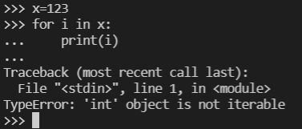

i = 0

while i < 5:

print(i)

i += 1

if i == 3:

break

else:

print(“error”)

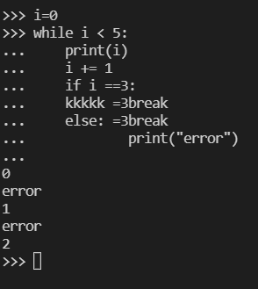

count = 0

while True:

print(count)

count += 1

if count >= 5:

Break

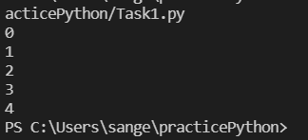

7. Write a program that prints all the numbers from 0 to 6 except 3 and 6.

Expected output: 0 1 2 4 5

Note: Use ‘continue’ statement

for x in range(6):

    if (x == 3 or x==6):

        continue

    print(x)

print("\n")

8. Write a program that accepts a string as an input from the user and calculate the number of digits and letters.

Expected output: consul72

Letters 6

Digits 2

user = input("Enter string with digits in it")

a,b = 0,0

for i in range(len(user)):

    if(user[i].isalpha()):

        a = a + 1

    else:

        b = b + 1

print("letters :", a, "\n digits :", b)

9. Read the two parts of the question below:

* Write a program such that it asks users to “guess the lucky number”. If the correct number is guessed the program stops, otherwise it continues forever.

number = int(input("Guess the lucky number "))

if number == 5:

    print("Thats the correct guess")

else:

    print ("That is not the lucky number")

* Modify the program so that it asks users whether they want to guess again each time. Use two variables, ‘number’ for the number and ‘answer’ for the answer to the question whether they want to continue guessing. The program stops if the user guesses the correct number or answers “no”. (The program continues as long as a user has not answered “no” and has not guessed the correct number)

again = "yes"

while again != "no":

    number = int(input("Guess the lucky number: "))

    if number == 5:

        print("Correct guess !!!")

        break

    print ("That is not the lucky number")

    again = input("Would you like to guess again? ")

10. Write a program that asks five times to guess the lucky number. Use a while loop and a counter, such as

counter=1

While counter <= 5:

print(“Type in the”, counter, “number”

counter=counter+1

counter = 1

while counter <= 5:

    number = int(input("Guess the " + str(counter) + " number"))

    if number != 5:

        print ("Try again.")

    else:

        print ("Good guess! Try again")

    counter = counter +1

else:

    print("Game Over!!")

The program asks for five guesses (no matter whether the correct number was guessed or not). If the correct number is guessed, the program outputs “Good guess!”, otherwise it outputs “Try again!”. After the fifth guess it stops and prints “Game over!”.

11. In the previous question, insert “break” after the “Good guess!” print statement. “break” will terminate the while loop so that users do not have to continue guessing after they found the number. If the user does not guess the number at all, print “Sorry but that was not very successful”.

counter = 1

while counter <= 5:

    number = int(input("Guess the " + str(counter) + " number "))

    if number != 5:

        print ("Try again.")

    else:

        print ("Good guess!")

        break

    counter = counter +1

else:

    print ("Sorry but that was not very successful")